* Submit the output of the following queries using sakila.sql:
  + List the number of inactive customers

* + List all the customers whose last name start with “A”. Order the list by first name in ascending order.

* + Are there any films with no category assignment?

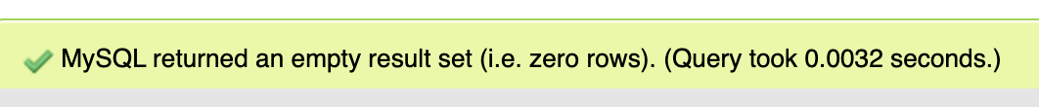

No, there is no film with no category assignment.

* + How many movies have the word “Drama” in their descriptions?

16 movies have the word “drama” in the description.

* + How many “Action” movies do we have?

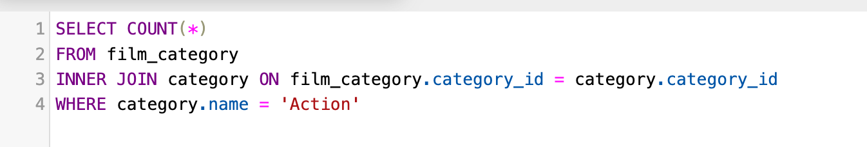

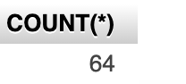

64 “Action” movies do we have.

* + How many customers live in Canada?

5 customers live in Canada.